Digital Camera D5000
PC Mode Specifications

Rev. 1.00

2009.03.13
Nikon Corporation
Imaging Company
2nd Development Department

Table of Contents

1. OUTLINE 3
2. PROCESS FLOW 3
2.1. USB Signal Lines 3
2.2. Finding USB 4
2.3. PTP / MTP 5
3. PC MODE 6
3.1. PC Camera Mode / PC Host Mode 6
3.1.1. PC camera mode 6
3.1.2. PC host mode 6
3.1.3. Auto meter-off delay 7
4. OPERATION ON THE CAMERA 8
4.1. Validity of Operation of Buttons/Dials 8
4.2. Possibility of Menu Item Setting 8
4.2.1. Playback menu 8
4.2.2. Shooting menu 8
4.2.3. Custom menu 9
4.2.4. Setup menu 9
4.2.5. Image editing menu 9
4.2.6. My menu 9
4.3. Available Operations for Functions 10
4.3.1. Shooting operation 10
4.3.2. AF operation 11
4.3.3. Live view 11
4.3.4. Two-button reset 11
4.3.5. Card operation (playback / deleting images / formatting) 11
4.4. Display Section of the Camera 11
5. SUPPLEMENTARY MATTERS 12
5.1. Battery Voltage Drop during Continuous Shooting 12

OUTLINE

These specifications define the PC mode as the situation in which the digital camera D5000 (hereinafter referred to as the camera) and the PC are connected by the USB and the USB communication has been established.
Although USB is also used for the connection with the wireless transmitter or the printer that supports PictBridge, this situation is not included in the PC mode.

The following protocol is adopted when connecting with the host in PC mode.
  - PTP/MTP (Image Interface)

For the detailed specifications of the protocols, refer to the specifications below.
- PTP/MTP: D5000 USB Still Image Capture Device Media Transfer Protocol (MTP) Specifications

PROCESS FLOW

This chapter describes the process when the camera is connected with the PC using USB.

USB Signal Lines

USB has the following signal lines.

1) V BUS
2) D+
3) D-
4) GND

- The condition for the camera to detect USB connection
5V current is supplied on V BUS line of the camera.

- The condition for the PC to detect USB connection
D+ line of the PC is pulled up.

Finding USB

In this section, the flowchart of the process on the camera is described when the camera finds USB.

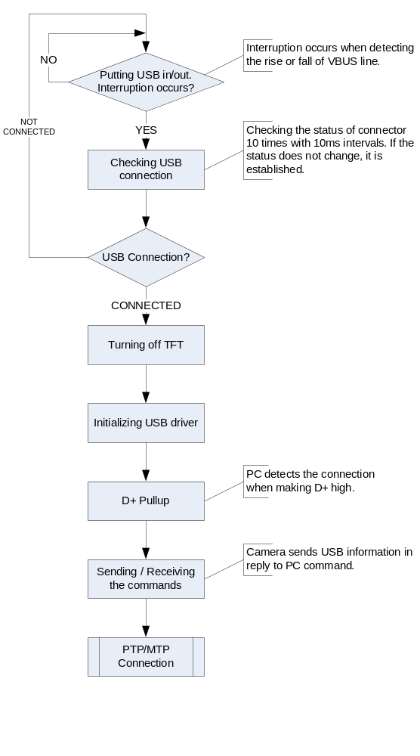

PTP / MTP

The flowchart of the process when the camera is connected in the PTP/MTP mode is shown below.

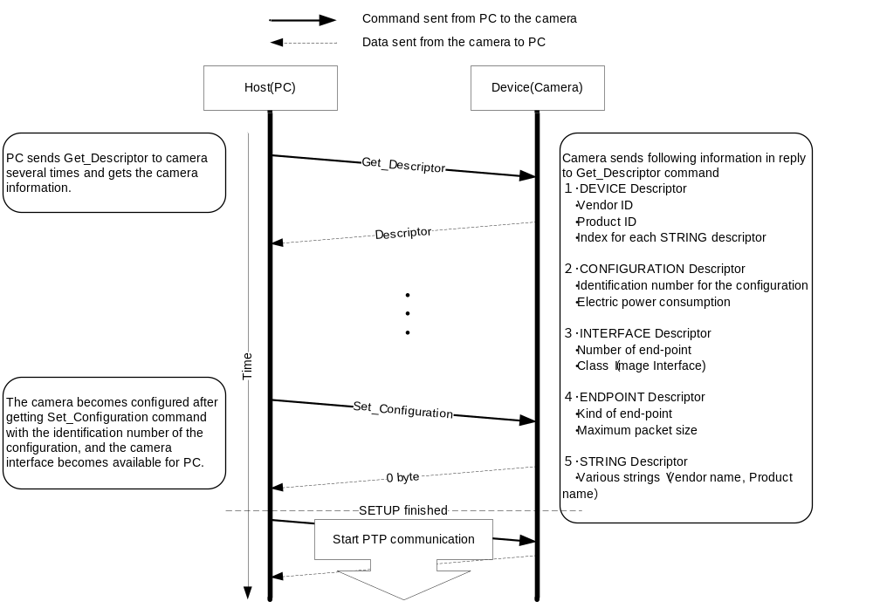

PC MODE

When the camera is connected to the PC with the USB cable, the camera automatically enters the PC mode.
When the USB cable is released, the PC mode is also released automatically.
The timing when shifting to the PC mode changes depending on the status of the camera.

Shifts to the PC mode after the processing is completed in the case below
  - During shooting (AF operation, release operation)
  - During formatting
  - During image recording to the card
  - During access to the card
  - During the preview operation

Aborts the processing and then shifts to the PC mode in the case below
  - During the self-timer operation
  - Formatting waiting status
  - Preset release waiting status
  - Dust reference release waiting status
  - During the TFT display (menu display / playback display)
  - During Live view (including the movie shooting)
  - Cleaning mirror-up operation waiting status

The camera does not shift to the PC mode in the cases below.
  - While the cleaning mirror-up operation is being performed
  - During the firmware updating
  - Battery level “Operation disabled status”
  - During the power interruption (during the power SW-OFF status in the camera)

PC Camera Mode / PC Host Mode

During PC mode, PC camera mode (targeted for the camera operation) and PC host mode (targeted for the PC operation) are supported, because the available functions on the camera vary depending on the status of use.
  - PC camera mode : This mode is used for the operation by the camera.
  - PC host mode : This mode is used for the operation by the PC.

PC camera mode

This is the default mode during the PTP/MTP connection.
During camera mode, the operation on the camera becomes valid and shooting by the shutter-release button of the camera is enabled (whether the captured image data is recorded to the card or transferred to the PC is described later).
The PC has no control of the operation section on the camera but the acquisition of the status is possible.
The control other than the operation section of the camera (such as the menu items) can be operated by the PC as well.
When the operation section is controlled by the PC in the PC host mode and the mode is switched to the PC camera mode, the control on the operation section made by the PC during host mode is canceled and the information of the buttons/dials on the camera is used.

PC host mode

When the host mode switching request from the PC is made or the command processing from the PC is executed during the PTP/MTP connection, the mode is switched to the PC host mode automatically.
For the automatic switching by the command processing, the mode is switched to the PC camera mode automatically after the processing is completed.
In the PC host mode, the operation of the buttons/dials (except the power switch) or menu of the camera becomes invalid and the operation from the PC becomes valid.

Auto meter-off delay

The Auto meter-off delay is set to “No limit” in the PC mode.

If the images remain in the camera buffer and the PC mode is released by disconnecting the USB cable when the recording destination is the PC, the Auto meter-off delay is left unlimited while those images remain in the camera buffer.

OPERATION ON THE CAMERA

The camera operation differs depending on the PC mode state.

The available operations in the PC camera mode and PC host mode are shown below.

Validity of Operation of Buttons/Dials

Whether the operation of the buttons/dials is valid or not is shown below.

Name of the operation section | PC camera mode | PC host mode
Power switch | Valid | Valid
Shutter-release button | Valid | Invalid
Exposure compensation / Aperture button | Valid | Invalid
Information button | Valid | Invalid
Shooting mode dial | Valid | Invalid
Flash / Sync mode / Flash compensation button | Valid | Invalid
Self-timer / Function button | Valid | Invalid
Main command dial | Valid | Invalid
AE/AF lock / Protect button | Valid | Invalid
Live view button | Invalid | Invalid
Multi-selector | Valid | Invalid
OK button | Valid | Invalid
Delete button | Invalid | Invalid
Playback button | Invalid | Invalid
Menu button | Valid | Invalid
Playback zoom-out / Thumbnail / Help button | Valid | Invalid
Playback zoom-in button | Valid | Invalid
Mode dial | Valid | Invalid

Possibility of Menu Item Setting

Whether the menu item can be set from the camera is described below.

Playback menu

(Yes: Operation is enabled. C: Some limitation exists. No: Operation is disabled.)
Menu item | PC camera mode | PC host mode
Delete | No | No
Playback folder setting | No | No
Playback screen setting | Yes | No
Auto playback after shooting | No | No
Auto image rotation, | Yes | No
Slide show | No | No
Print setting (DPOF) | No | No

Shooting menu

(Yes: Operation is enabled. C: Some limitation exists. No: Operation is disabled.)
Menu item | PC camera mode | PC host mode
Scene mode | Yes | No
Picture Control | Yes | No
Custom Picture Control | C (*) | No
Image quality mode | Yes | No
Image size | Yes | No
White balance | Yes | No
ISO sensitivity setting | Yes | No
Active D-Lighting | Yes | No
Auto distortion control | Yes | No
Color space | Yes | No
Long exposure noise reduction | Yes | No
High ISO noise reduction | Yes | No
Recording folder setting | No | No
Movie setting | Yes | No
Interval-timer shooting | No | No
*1. “The memory card is used.” cannot be operated.

Custom menu

(Yes: Operation is enabled. C: Some limitation exists. No: Operation is disabled.)
Menu item | PC camera mode | PC host mode
Custom menu (all items) | Yes | No

Setup menu

(Yes: Operation is enabled. C: Some limitation exists. No: Operation is disabled.)
Menu item | PC camera mode | PC host mode
Formatting the card (Format) | No | No
Brightness of the liquid crystal monitor | Yes | No
Design of information display | Yes | No
Automatic information display | Yes | No
Information setting wrap-around | Yes | No
Image sensor cleaning | Yes | No
Cleaning mirror-up | No | No
Video output | Yes | No
HDMI | Yes | No
World time | Yes | No
Language | Yes | No
Image comment | Yes | No
Recording the lengthwise/widthwise position information | Yes | No
Image dust off data acquisition | Yes | No
GPS | Yes | No
Firmware version | C (*) | No
*1. The firmware version upgrade is disabled.

Image editing menu

(Yes: Operation is enabled. C: Some limitation exists. No: Operation is disabled.)
Menu item | PC camera mode | PC host mode
Image editing menu (all items) | No | No

My menu

This is consistent with the each menu item.

Available Operations for Functions

Available operations on the camera are shown below.

(Yes: Operation is enabled. C: Some limitation exists. No: Operation is disabled. )
Function |  | Operation on camera |  | Operation on PC
 |  | PC camera mode | PC host mode | PC camera mode | PC host mode
Shooting operation | Single frame shooting | Yes | No | Yes (*) | Yes
Shooting operation | Continuous shooting | Yes | No | Yes (*) | Yes
Shooting operation | Self-timer shooting | Yes | No | C (*) | C
Shooting operation | Quick-response remote shooting | Yes | No | C (*) | C
Shooting operation | Delayed remote shooting (2s delay) | Yes | No | C (*) | C
Shooting operation | Quiet mode shooting | Yes | No | C (*) | C
Shooting operation | Bulb shooting | Yes | No | No | No
Shooting operation | Preset data acquisition | Yes | No | Yes (*) | Yes
Shooting operation | Image dust off data acquisition | Yes | No | C (*) | C
AF operation |  | Yes | No | Yes (*) | Yes
Live view |  | No | No | Yes (*) | Yes
Two-button reset |  | Yes | No | No | No
Card operation | Playback of image | No | No | Yes | Yes
Card operation | Deletion of image | No | No | Yes (*) | Yes
Card operation | Card formatting | No | No | Yes (*) | Yes
* The mode is changed to the PC host mode temporarily

Shooting operation

The shooting operations in the PC mode are shown below.

Image data recording destination

The image data captured by the shooting operation in the PC mode are recorded in the card or transferred to the PC.

The images captured by the shutter button of the camera are recorded according to the destination setting.
The recording destination setting can be changed by the MTP (PTP) command.

When the PC captures the image, the recording destination is decided by the MTP (PTP) command that the PC uses. (The destination setting is ignored when the PC captures images.)

Single frame shooting

The operation from the PC is the same as the operation from the camera.

Continuous shooting

When the operation is performed from the PC, the number of maximum continuous release is specified by the PC.
The number of maximum continuous release can be changed by PTP/MTP command.

Self-timer / quick-response remote / delayed remote / quiet shooting

When the operation is performed from the PC, shooting mode is switched to single frame shooting.

Bulb shooting

The bulb shooting is disabled because the “keep pressing the shutter-release button” situation cannot be reproduced by the command operation from the PC.

Preset data acquisition

If the operation is performed by the camera and it fails to acquire the preset data, the operation continues. However, if the operation is performed by the PC and it fails to acquire the preset data, the operation is terminated.
In addition, when the operation is performed by the PC, the preset data can be acquired even if the white balance is set to other than the preset manual.

Image dust off data acquisition

If the operation is performed by the camera and it fails to acquire the image dust off data, the operation continues. However, if the operation is performed by the PC and it fails to acquire the image dust off data, the operation is terminated.
In addition, when the operation is performed by the PC, the image data is not recorded in the card because only PC is supported as the recording destination.

AF operation

The operation from the PC is the same as the operation from the camera.

Live view

Live view display on the PC is supported, but that on the camera is prohibited.

Two-button reset

This is not supported for the PC operation.

Card operation (playback / deleting images / formatting)

Card operation from the PC is supported, but that from the camera is prohibited.

Display Section of the Camera

The display conditions of the display in the finder/the LCD monitor change depending on the connection mode and the recording destination setting.
Each display condition is shown below.

Connection mode | Recording destination | In the finder | LCD monitor
PC camera mode | Card | Normal display | Normal display
PC camera mode | PC | The number of images that can be captured: PC display | The number of images that can be captured: PC display
PC host mode | Card | PC display only | PC host mode display
PC host mode | PC | PC display only | PC host mode display

SUPPLEMENTARY MATTERS

The supplementary matters are described below.

Battery Voltage Drop during Continuous Shooting

When the camera is operated by using the battery and the continuous shooting is invoked by the PC, there is a possibility that the battery voltage may drop and become on the shooting prohibition level during continuous shooting.
In this case, shooting is terminated when the voltage drop is detected even if the number of captured images does not reach the specified number of images.
When the recording destination is the PC, the image data is transferred to the PC. However, the connection with the USB may not be established depending on the battery voltage drop level.
In this case, the image data is not transferred because the PC mode is released.

